**Critical Design Review**

**1. Agenda —** outline of review material:

* Introduction
* Design overview
* Results of periodical completion of phases
* Changes to system operation since PDR
* Changes to major software components since PDR
* Changes to testing strategy
* Required resources
* Changes to the SDMP since the PDR
* Milestones and schedules
* Issues, risks, and problems

**2. Introduction —** The purpose of this proposed project is to develop an IoT platform that will monitor the available parking spaces in a parking structure. In efforts to help reduce the amount of time taken to find available spaces, this system would be developed to help alleviate the amount of time it takes for people to find a space to park their vehicles by managing and displaying available spaces.

**3. Design overview —** major design changes since PDR (with justifications)

a. Design diagrams, showing products generated, interconnections among subsystems, external interfaces

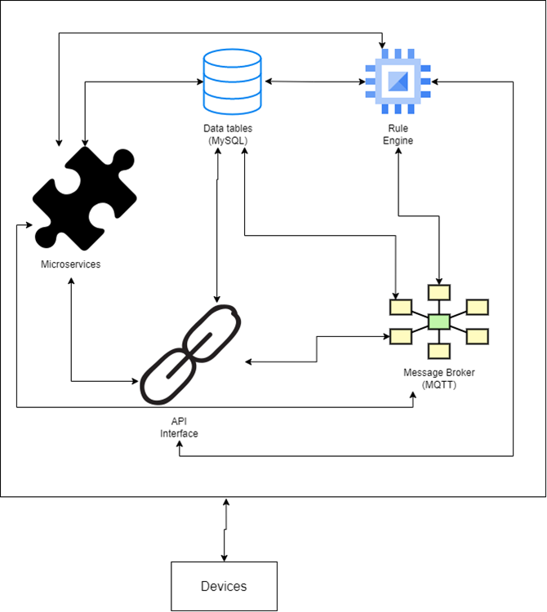

No major changes have been made to the design since the PDR

**4. Results of periodical completion of phases –** The results of completion of project phases has resulted in a functional message broker to broadcast messages on the platform, a functional database to store the required data, a functional rule engine, and an API for interfacing with the external devices.

**5. Changes to system operation since PDR –** No changes have been made to the system operation since the PDR.

**6. Changes to major software components since PDR (with justifications)** - No major changes have been made to the major software components since the PDR.

**7. Changes to testing strategy –** No changes have been made to testing strategies since the PDR. All testing strategies are derived from the suggested project guidelines. Testing is done at regular intervals to ensure that each block created for the IoT platform functions as expected.

**8. Required resources -**

A. Hardware:

* Wireless routers (IEEE 802.3ac)
* Proximity devices with WiFi capabilities
* Output display monitors
* Laptops, Personal Computers, and/or access to a computer laboratory

B. Software:

* Creation of Virtual hosts for cloud environment
  + Minimum 2 GB of RAM
  + Minimum 50 GB of secondary storage
* DigitalOcean services
* LAMP
* RedNode
* Microsoft Teams software
* Microsoft word
* Microsoft project

C. Other resources:

* A team of 5 students
* Monetary resources if needed
* “Recommended Approach to Software Development” published by NASA, June 1992

**9. Changes to the SDMP since PDR –** No major changes have been made to the SDMP since the PDR was documented.

**10. Milestones and schedules -**

* Chapter 5: Due June 26. 2022
  + Systems and Operations Concept Document
  + Requirements Specification document
  + Project Description
* Chapter 6: Due July 3, 2022
  + Software Development/Management Plan
  + Requirements Analysis Report
* Chapter 7: Due July 10, 2022
  + Preliminary Design Report
* Chapter 8: Due July 17, 2022
  + Detailed Design Document
  + Critical Design Review
* Chapter 9: Due July 24, 2022
  + Test Plan Outline
  + Build Design Review
* Chapter 10: Due July 31, 2022
  + System Description
* Chapter 11: Due August 7, 2022
  + Software Development History

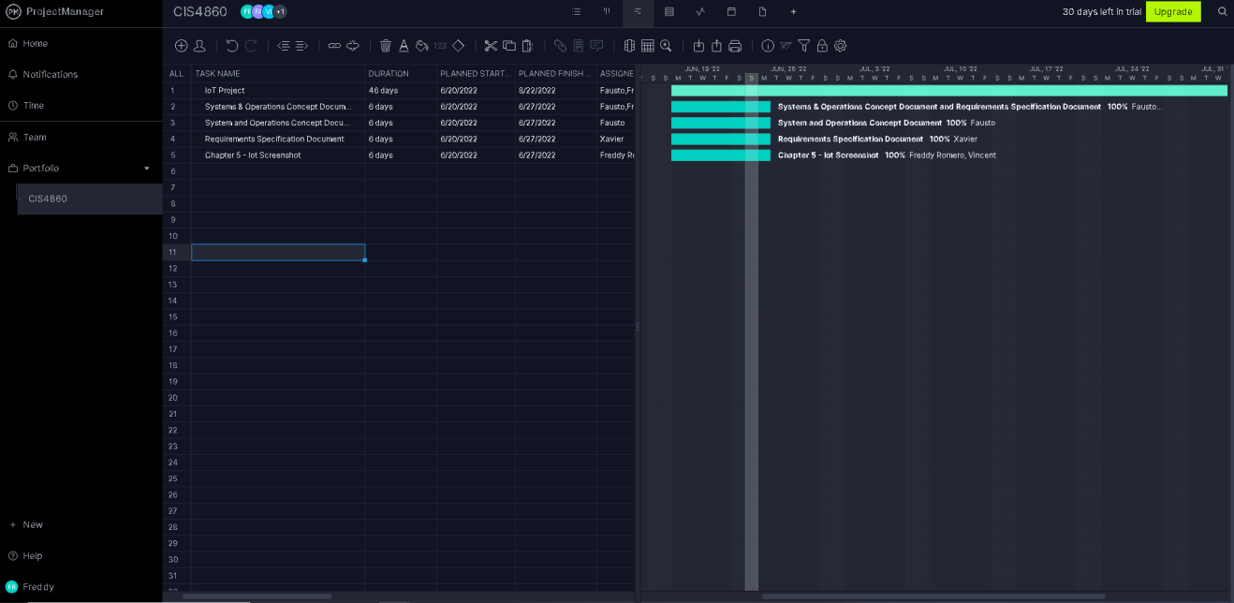

**11. Issues, risks, problems -**

* IoT Platform change of requirements – Any changes to the platform requirements will cause delays in the schedule and delay of product deployment.
* Delay of shipment of required hardware – Any unforeseen delays of shipments for the necessary hardware such as vehicle proximity sensors and network gateways would cause delays in the schedule and delay of product deployment.
* Database security risks – The security of the database in the IoT platform may have unforeseen risks that could affect the confidentiality and integrity of the database. It must be assured that all vulnerabilities are to be patched so that unauthorized access to the database is prevented and the data in the database cannot be changed without authorization.